RESUME

Post Applied For : English Trainer
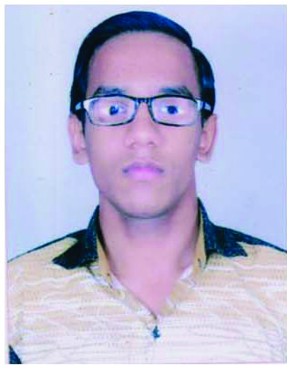
Photo
Discipline : B.BA., Applied for B.ed
Name : Priyansh Agrawal
Date of Birth : 16 Jan 2001
Present address : Kachi Sadak, Masani, Mathura 281001
Email ID :Priyanshagrawal4990@gmail.com
Mobile : 9897418559, 9897928559
Category : General

- Qualifications
Degree | Degree Name | Passing Year | Board/University | %age
Post Graduation
Graduation. | B.B.A. | 2021 | Dr. B.R.A. University Agra | 70%
Intermediate | 12 | 2018 | P.D.D.S.V.M. VRINDAVAN, C.B.S.E. | 75%
High School | 10 | 2016 | P.D.D.S.V.M. VRINDAVAN, C.B.S.E | 78%
Any Other

- Experience: Detail of Experience possessed in the chronological order, starting with the latest, (do not include Experience below complete one year):

S. No | Post held | Current Gross Salary | Organization | Duration |  | Experience in (Years & Months)
 |  |  |  | From | To | Experience in (Years & Months)
1 | Facilitator | 18700 | Freedom English Academy | 2020 | 2022 | 2 Years
2 | Sales Executive | 7000 | Swastik Astrology | 2019 | 2020 | 1 Year
3 | Office Assistant | 6000 | Private coaching centre | 2018 | 2019 | 1 Year
4
5

- Achievements: English Trainer

Personal Profile
Father’s Name : Mr. Dileep Agrawal
Marital Status : Unmarried
Permanent Address : Kachi Sadak, Masani, Mathura

- References : (1)Name :
Address :

Contact Details :

(2) Name :
Address :

Contact Details :

Declaration: I, hereby, declare that all the information mentioned herein by me above is true to the best of my knowledge.

Place : Mathura Name: Priyansh Agrawal

